4204113 - Financial Document Formula Drill-Down
[EM] Financial Document Formula Drill-Down in Excel and Word (Epic 4204113)1. Customer Problemcannot see how a reported number is composed (codes, subcodes, accounts) without manual tracing, slowing audits and increasing risk.
2. Customer Researchincludes detailed example and table; parity requested with PFX Engagement and CSA.
3. Our SolutionOffice add-in Drill Down action reads cell formula, resolves account groupings/tax codes and individual accounts, and generates a detail report.
- Honors period and balance type; supports multi-group formulas.
Dependencies: add-in, reporting services, formula parser.
4. Product MetricsTime to validate a number: -50%.
- Reviewer satisfaction: +10 pts.
- Mismatch rate between drilldown and formula: 0%.
Appendix: Child Features4208966 Comprehensive Formula Drill-Down Capability
Appendix: Quick prototypeembedded table example in epic; also reference PDF for division-based examples.
Appendix: LinksHYPERLINK "https://dev.azure.com/tr-tax/TaxProf/_workitems/edit/4204113"Open Epic 4204113

Appendix: Quick prototype
Figure: PDF page 1
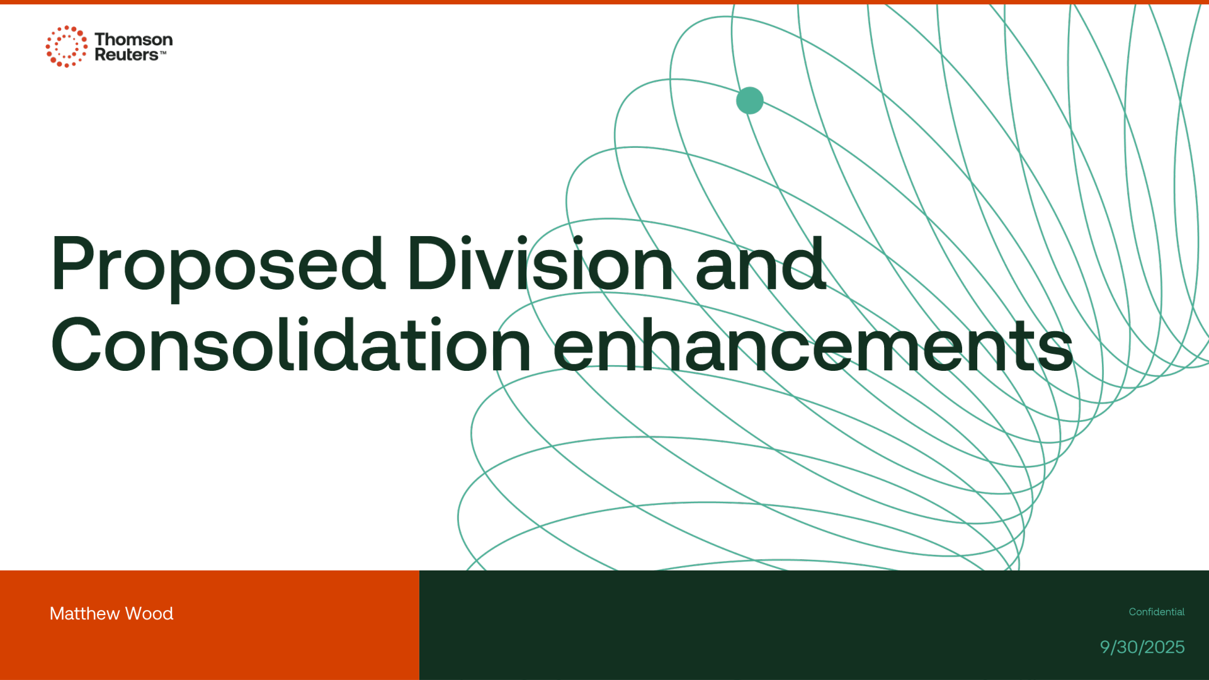

Appendix: Links
ADO Epic Link: https://dev.azure.com/tr-tax/TaxProf/_workitems/edit/4204113

